Front End
. HTML
. CSS
. JAVASCRIPT
. BOOTSTRAP
. ANGULAR
. REACT
. AJAX
. JQUERY

Back End
. C++
. PYTHON ==> Django
. PHP ==> Laravel
. JAVA
. dotNET
(Related frameworks)

Database
. MySql
. Sql
. Mango DB
. Oracle

Cloud Computing
. AWS
. AZURE
. GOOGLE CLOUD

Testing
. Manual

Data structures and algorithms
Artificial Intelligence
Machine Learning
Data Science
Big Data
Blockcain
Cyber Security
Ethical Hacking
Docker

https://github.com/manikumarkv/webtechTrainings/invitations

https://reactjs.org/docs/create-a-new-react-app.html#create-react-app

https://intellisavvy-web-training.netlify.app

https://www.codingninjas.com/blog/2021/01/02/10-programming-languages-with-data-structures-algorithms/

https://www.tutorialspoint.com/sql/sql_tutorial.pdf

w3schools.com/sql/sql_join.asp

React
======

https://www.youtube.com/c/TheNetNinja/playlists

https://www.youtube.com/watch?v=zb3Qk8SG5Ms&list=PL4cUxeGkcC9jsz4LDYc6kv3ymONOKxwBU&ab_channel=TheNetNinja

https://www.youtube.com/watch?v=yZ0f1Apb5CU&list=PL4cUxeGkcC9i0_2FF-WhtRIfIJ1lXlTZR&ab_channel=TheNetNinja

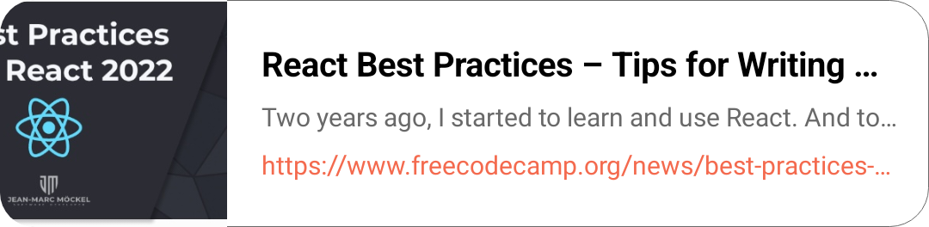
https://youtu.be/OcM__8q6p4c

Javascript30
Hackerrank

